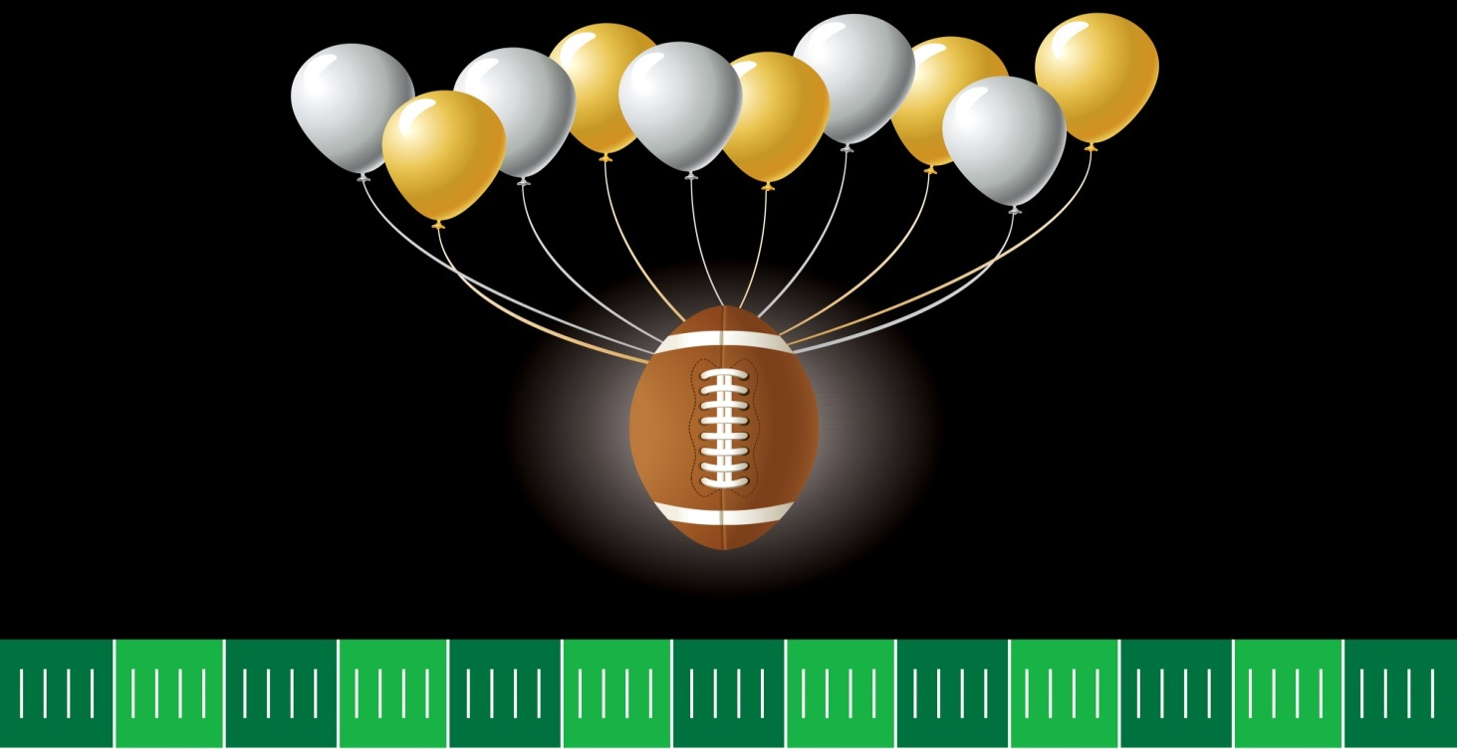

**Sunday, October 2nd**

**12:00 – 5:00 pm**

E. 13th St. between Jefferson & Madison St., Lockport

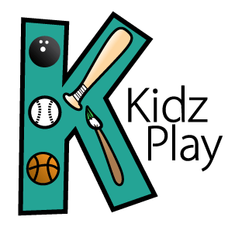

Admission is free!

Watch the Bears Game, Bean Bag Tournament, Prizes, Concessions Available for Purchase, Raffles & More to Benefit Kidz Play, nfp.

*For more information contact us at* [*helpkidzplay@gmail.com*](mailto:helpkidzplay@gmail.com)